Episode 127: You think you’re productive, but you’re not
Welcome back, sweet sister. I hope you’re enjoying this podcast and if it’s your first time here, these sessions might be just the perfect length to go back and binge-listen. I’m Mridu Parikh, I help ambitious women business owners wake up with a plan that works. Btw, if you have left me a podcast review, thank you so much. It lights me up and truly means the world to me. Here is one from FlameRetardant which is actually from a while back but here I’m just reading it now….
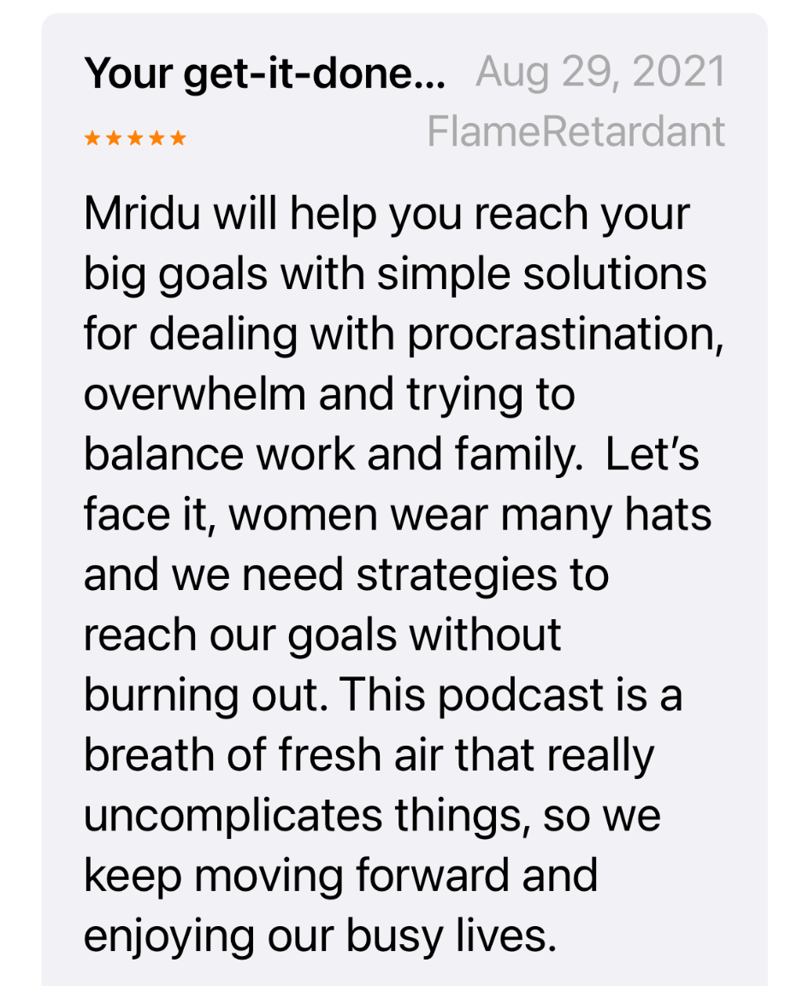
If you haven’t, how about now…?

Right now my kids and probably yours if you have kids are on summer break. Break was so much fun --- even if you loved school, you couldn’t wait until the end of the year to not have to do homework or sleep in and hang out with your friends. And the same of course went for the fall breaks, holiday breaks, and spring breaks. We all need breaks. If you want to have a full and rewarding life you need to time to step away from your day to day, have space mentally, emotionally, and physically, so you can recalibrate and reset and feel rejuvenated.

So I hope that regular breaks whether it’s two weeks away, one weeks away or weekends, is a regular part of your life. And actually this episode is not specifically about that but I do want to start here, from a high-level and the importance of breaks.

But related to that, it is equally important to take breaks during your day. And that’s where we going today. You might know you need to take breaks but I before you check out of this episode I want you to know I’m going to cover two very important things:
- The right way to take breaks - yes there is a right way - that actually feels productive and is productive and can be a massive investment in your life and gets you significantly closer to your goals. Yes it’s that serious.
- And the wrong way to take breaks. Yes there is wrong way - and when you do it this way you rob yourself of the life you want. Yes, it’s that serious.

Okay, so I touched upon why taking breaks is so important, but that was more weekly on the weekends or quarterly with a vacation but I’m going to spend two minutes on why it is imperative to take breaks during the day. To stop feeling like taking a break is a waste of time. And to acknowledge that breaks can be the catalyst for your creativity, leadership, and overall energy.

You might not be taking breaks because you think you’ll be looked down upon or makes you look lazy or unmotivated or is just a great waste of time. When you don’t have a minute to breathe the last thing you’re thinking is: oh, let me just leave my 400 unread emails and 30 client demands and go take a stroll in the park. But the truth is, this is backward thinking. The question you should be asking yourself is: What can I do to more effortlessly get through my 400 emails and 30 client demands? And often, one of the strategies is to take a short break. Here are some break benefits:
- Can prevent decision fatigue
- Increases productivity
- Improves mental health and well-being
- Increases job satisfaction
- Restores focus and attention, especially for long term goals
- Increases creativity
- Movement breaks are helpful for emotional and physical health
- “Rest” helps with memory and improves learning
- Lowers stress by allowing time to decompress

How breaks can make you feel very productive, but they’re not

Here’s the wrong way to take a break:
I’m burnt out, I need a break so I’m going to jump onto social media. My brain is fried so I’m going to turn on Netflix. Or I’ll stop trying to figure out this problem that I can’t solve or put off dealing with this overwhelming project and I’ll jump into email. The best thing about email is that it feels so productive right? You’re like, well I can’t figure out this one thing, BUT not a big deal because I’m crossing emails off my list like a badass. Contrary to popular belief, this is no bueno.

This is why taking breaks can be dangerous. It’s not awesome when you take a break because you’re confused or overwhelmed and just don’t know what to do and are procrastinating. OR When you your 5 minute break turns into a 45 minute break and you’re wondering where your day went.
And I totally understand what happens, because of course it happens to me to from time-to-time. You are about to take yourself off course and it feels so harmless. Like it’s not a big deal. In fact, I just listed like 10 reasons why you SHOULD be taking a break. I’ll just be 5 minute on Instagram, what’s the big deal? But often in situations like these, you are not thinking through the consequences of the decision you’re about to make or have any parameters around them. Like really, if I get on social for a 5 minute scroll there’s a good chance I’ll be on it for 35 mintues. Or if you work from home and think, I’ll just throw in some dishes to take my break, but then that actually leads to emptying the dishwasher, loading it, and cleaning the counters, and now it’s 40 minutes later. There’s no time limit around your break…Other than perhaps an intention. You’re probably telling yourself in your brain that I’m going to take a 5-minute break. Right, you have the right intention. BUT without parameters or thinking through next steps, the intention is more or less worthless (although it sure does make you feel good) because you don’t have the follow through plan in place. It feels so harmless to go off course but it’s not.

Okay so those are some big mistakes but here’s another one. This is a really big and sneaky one. So sneaky. And I very quickly mentioned this earlier.
When you are working on or even thinking about something that is very challenging or overwhelming your mind, when you’re struggling with something, while you’re thinking about it, while you’re brewing, you’re like, oh wait, I’ll just go check my email - because it’s easier. So that I feel like I’m doing something in between instead of working through the challenge. Instead of thinking through what are the next steps to get me through this challenge? You’re essentially like I’ll just replace this hard thing with the easy thing so I feel good but in reality you’re procrastinating the thing you really should be working on.

So this takes me to the RIGHT way to take breaks and I’m gonna go backwards here and address what I was just talking about and then go back to the other ways you could be taking breaks the wrong way.

So if you’re replacing this hard thing with the easy thing so you feel good but you’re actually procrastinating the thing you really should be working on.
One very very simple hack for this is to…change your state. To change your physical environment. To actually get your ass out of your seat and go walk around. It could be to walk to get a drink and hydrate or go take a walk around the block or walk. But the key is to yes, take a break, because you need to get out of your own head and clarity, but you MUST take a physical break. This is not a mental stimulation like jumping into email. You are not replacing that time to get through the struggle with something mental. You’re not replacing it with email or IG - you’re replacing it with something physical.

Other ways to take breaks the right way, so you do actually get the benefits like:
- preventing decision fatigue, increasing productivity, increasing creativity, lowering stress, restoring focus and attention
Is to:
- Use an actual timer. For reals. Not in your head. Not I’ll glance at my watch and then forget what time it is 20 seconds later - but actually use a timer for 5 to 10 minutes
- Do an activity that uses a different part of the brain than was being used for work, which allows the part of the brain being used for work to rest
- Be fully detached from work during the break
- Try to be active during the break
- When feeling too busy to take a break, do it anyway. It doesn’t have to be long. It could be 3-5 minutes, but it will help bring your blood pressure down, get your head to stop swarming. Btw, part of your break could be a brain dump. Spend 5 minutes brain dumping & 5 mins walking and I bet you’ll come back to you work with much more clarity

Got it. Remember, breaks are good. Breaks are necessary. Breaks will make you more productive IF and only if you use them the right way.

If you haphazardly take them without a plan or parameter, you are likely to go down a rabbit hole of time wasting and despair and robbing yourself of the life you want. Yes, it is that serious.
If you are taking them as a way to not deal with the hard stuff, you are likely to go down a rabbit hole of procrastination and not feeling good about what you achieve and are robbing yourself of the life you want. Yes, it is that serious.
It’s in those moment that you have an opportunity to retrain your brain. To say I’m not going tol replace the hard thing with the easy thing. I’m going to get my butt up and go walk around the block, put on my favorite song, and recalibrate, or reenergize or just step away and reset. It’s an opportunity for you to throw on an 8-minute timer so you disengage from what you’re doing and go talk to your mom instead but only for 8-minutes so you rerecalibrate, or reenergize or just step away and reset - without wasting time you just can’t account for later.

Take deliberate breaks regularly throughout the day and see how awesome and productive and more in control and less stress you feel.

Okay so you know I always love to leave you with a challenge. You’ve spent your last 20 minutes with me and I want to make your time with me 100% worth it. So today’s action is plan your breaks for tomorrow. How long will your breaks be? What will use to time them? What would be a good thing to do to change your state? In other words to change your environment while staying on track and focused for the day? You know I’d love to hear from you. So come on over to lio.com/podcast and let me know or on IG.

If you love getting permission to take breaks and now feel more confident about how to do it effectively and would love to support on how to make tweaks to many of your business and life practices so you feel kick-ass every day, I am inviting you to have a no-pressure, no obligation conversation with me. Just have a conversation about how you’re feeling, get to the root of what’s keeping you stuck, and see how to get out of it -- quickly. If you’re looking to put up better boundaries, craving more structure and want to get out of constant reactivity mode, we should talk. Go to lio.com/coaching. Click on the button that says: Apply for your free no-pressure consult now. On that call, I’ll ask you questions about what’s keeping you stuck. If I feel like I can help I will let you know and you can decide if you want to be a part of it. I hope you will take a leap of faith and connect with me. Remember, I believe you can get everything you want when you have the control you’ve worked so hard for.

As always, you are the best for showing up here. I thank you from the bottom of my heart for your time and loving vibes and positive energy. Know that I am sending them right back your way! Here’s to getting more of the right things done and embracing productivity on purpose. I will catch you next time!

